Passo Design Sketch

### PREPARED BY

**Abd Al-Ala Camara – UX Researcher**

31 January 2021

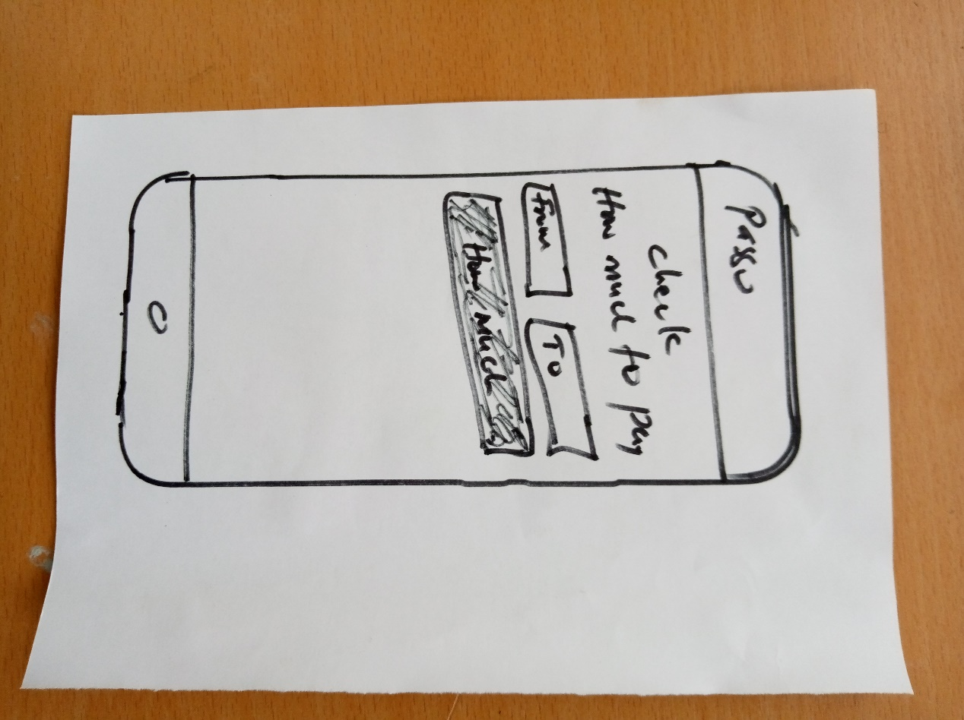

Check Fare Result  
Iteration 1

**What it is about**Once the user click on **How Much?** the result (fare) will show under the form

Check Fare  
Iteration 1

**What it is about**The check fare page help users to quickly check the fare from one locality to the other.

**Actions for users to take**Users can click on **From** and **To** to type fro and to, while the user is typing auto complete of the name of the locality should appear for the user to click instead of typing the whole locality name.

Once the user does that, the user can click on **How Much?** to see the fare

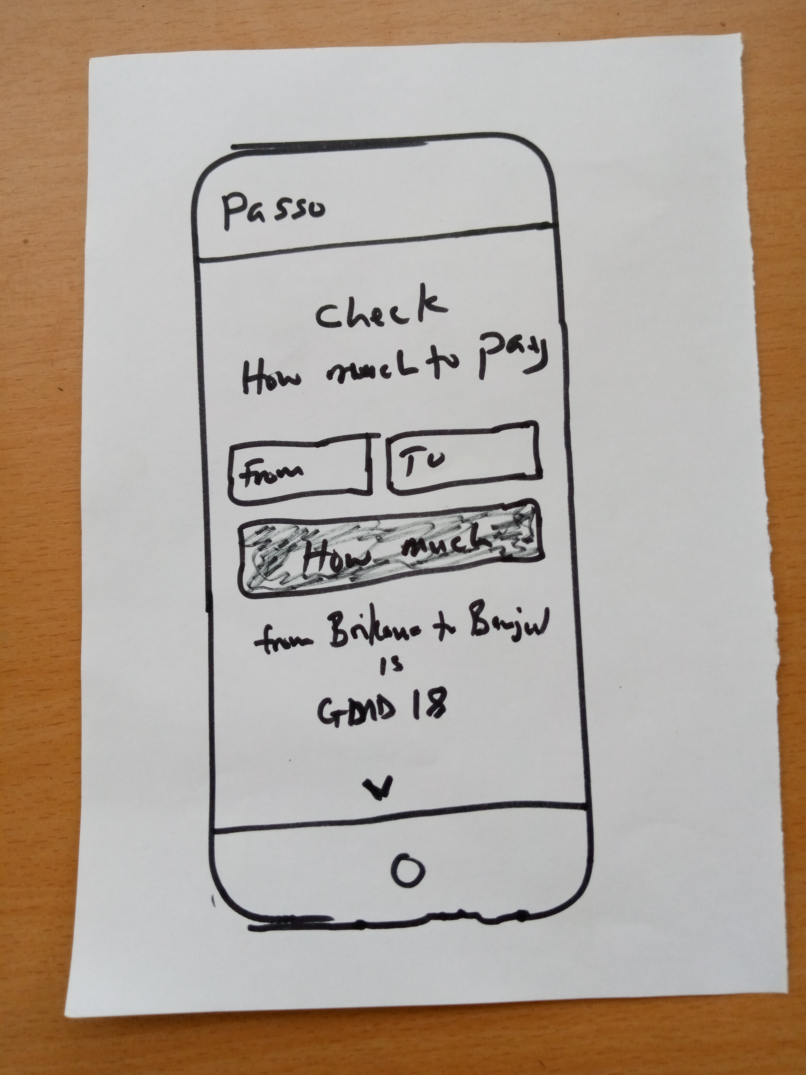

All fares  
Iteration 1

**What it is about**A listing of the fares arrange according to regions. User can quickly scan the fare as well.

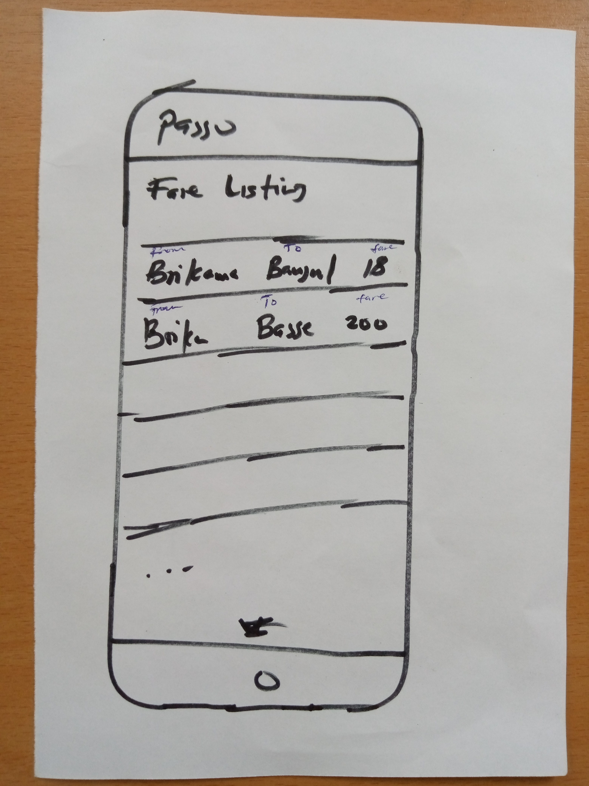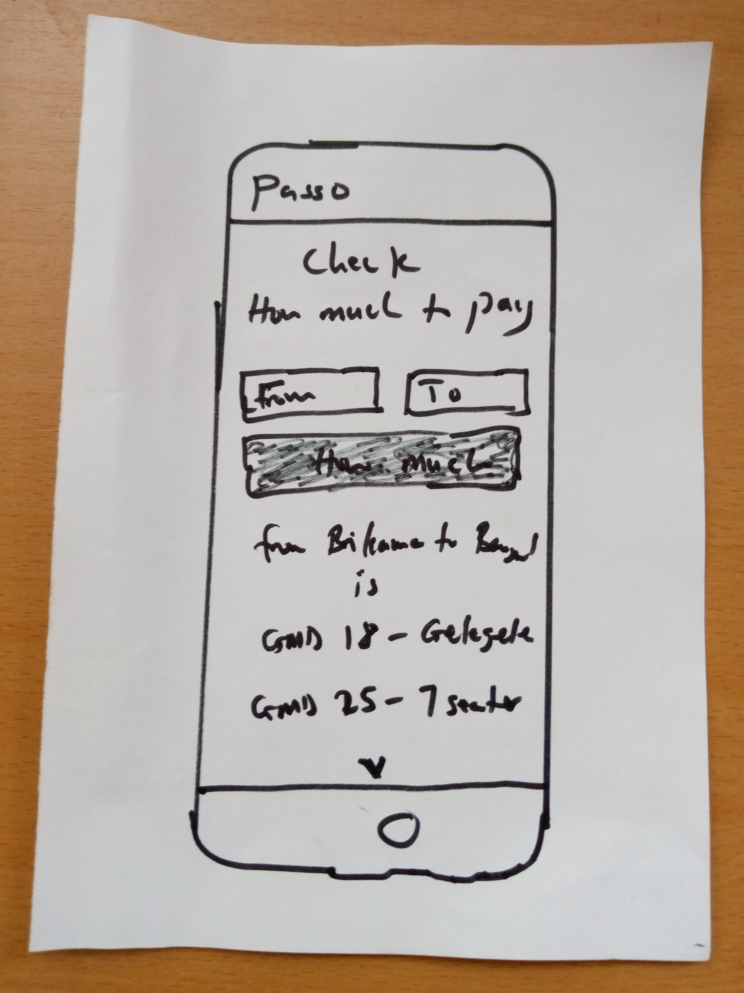

Check Multiple Fare Results  
Iteration 1

**What it is about**If a **From** and **To** has multiple fares base on the vehicle type, once the user click on **How Much?** the results (fares) with the vehicle type will show under the form.

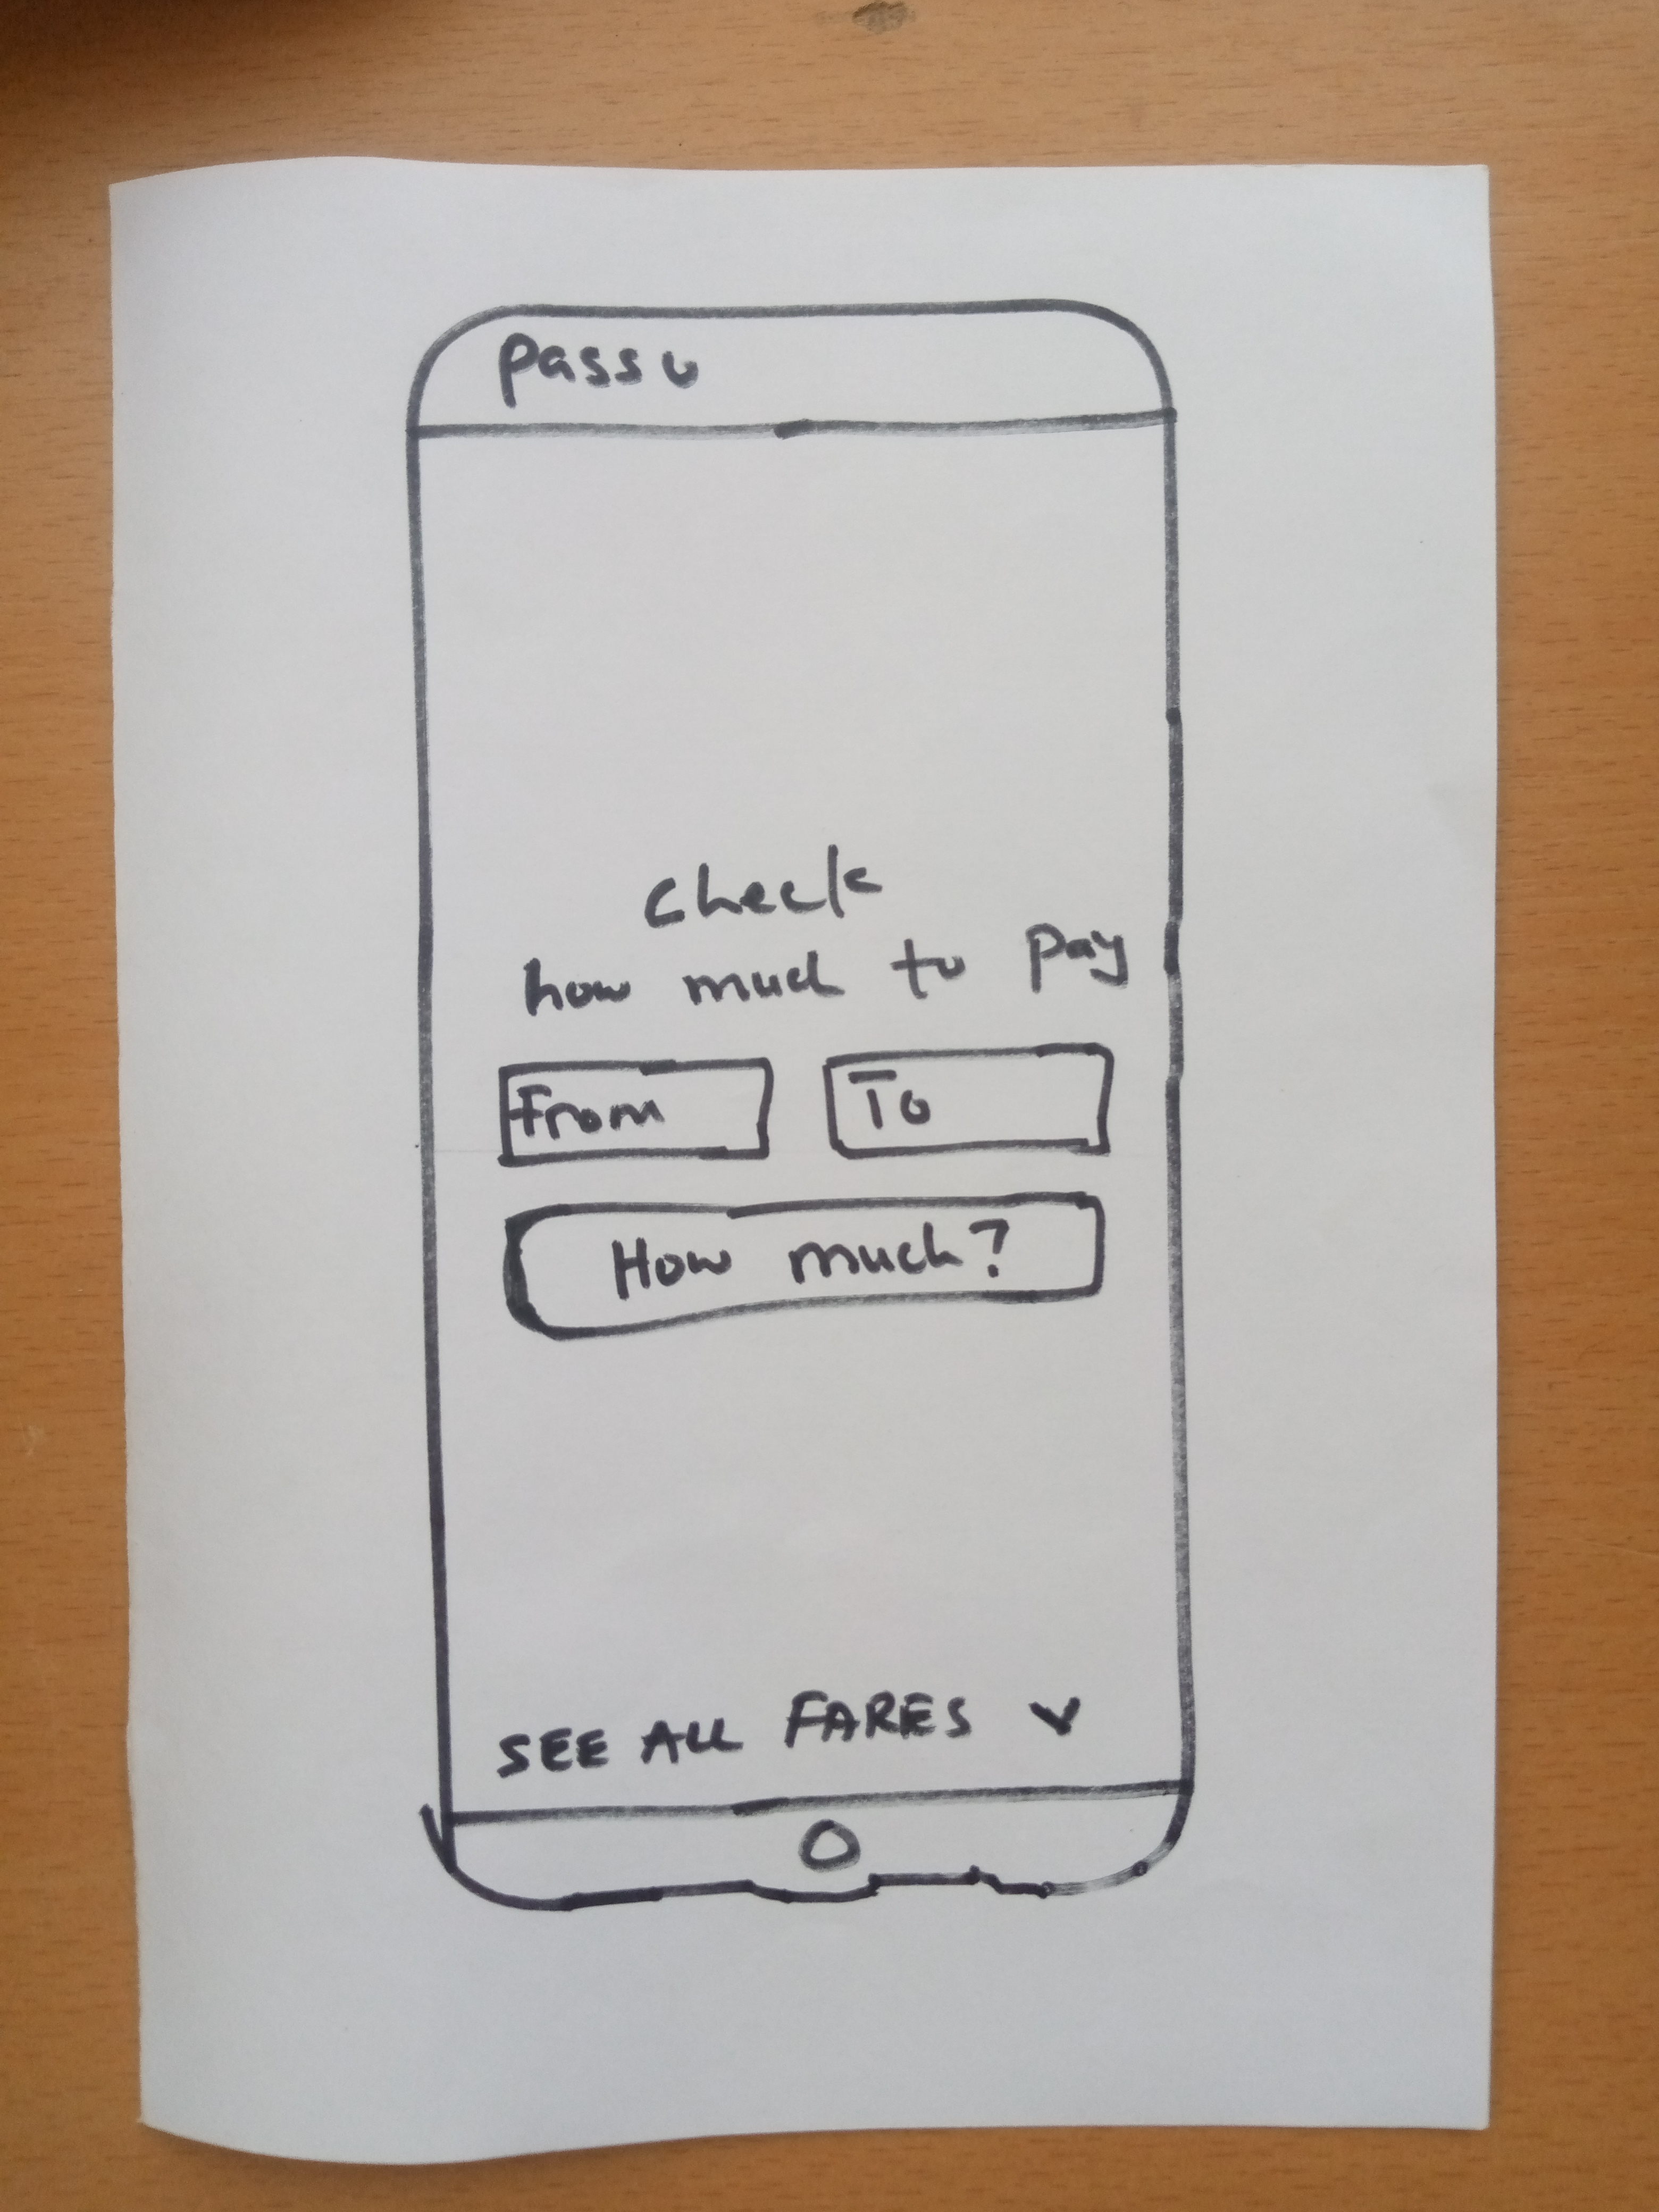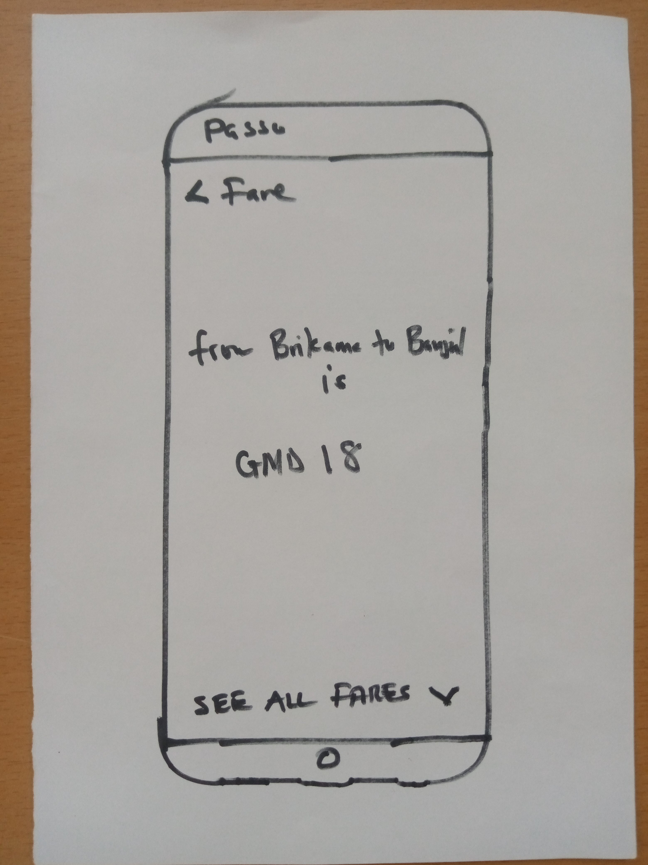

Check Fare Result  
Iteration 2

**Design principle(s) applied**

* Reduce the things on the fare page
* Add header and back button

**Designs rationale**

* Move the result of the fare to its own space, so that users will only focus on that. Once a user clicks on **How Much?** the results will slide in from bottom and replace the form.

Check Fare  
Iteration 2

**Design principle(s) applied**

* Check fare position
* Only the icon might not tell well

**Designs rationale**

* Centered the fare form and header where users eye will go
* Readability, users will make more sense when they see **SEE ALL FARES** than just an icon

All fares  
Iteration 2

**Design principle(s) applied**

* Add a proper header **ALL Fares**

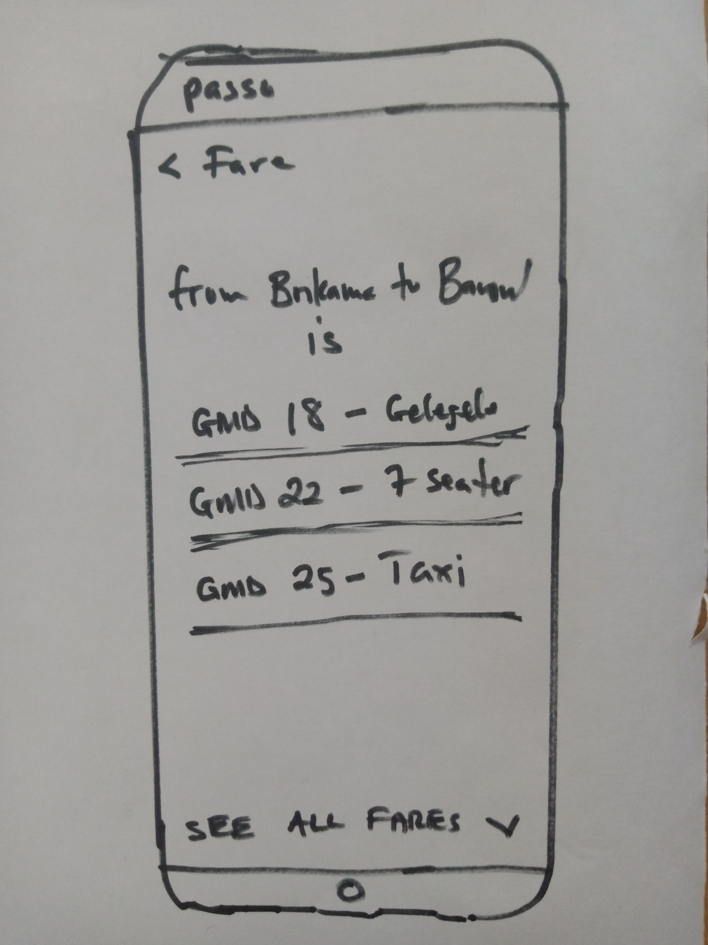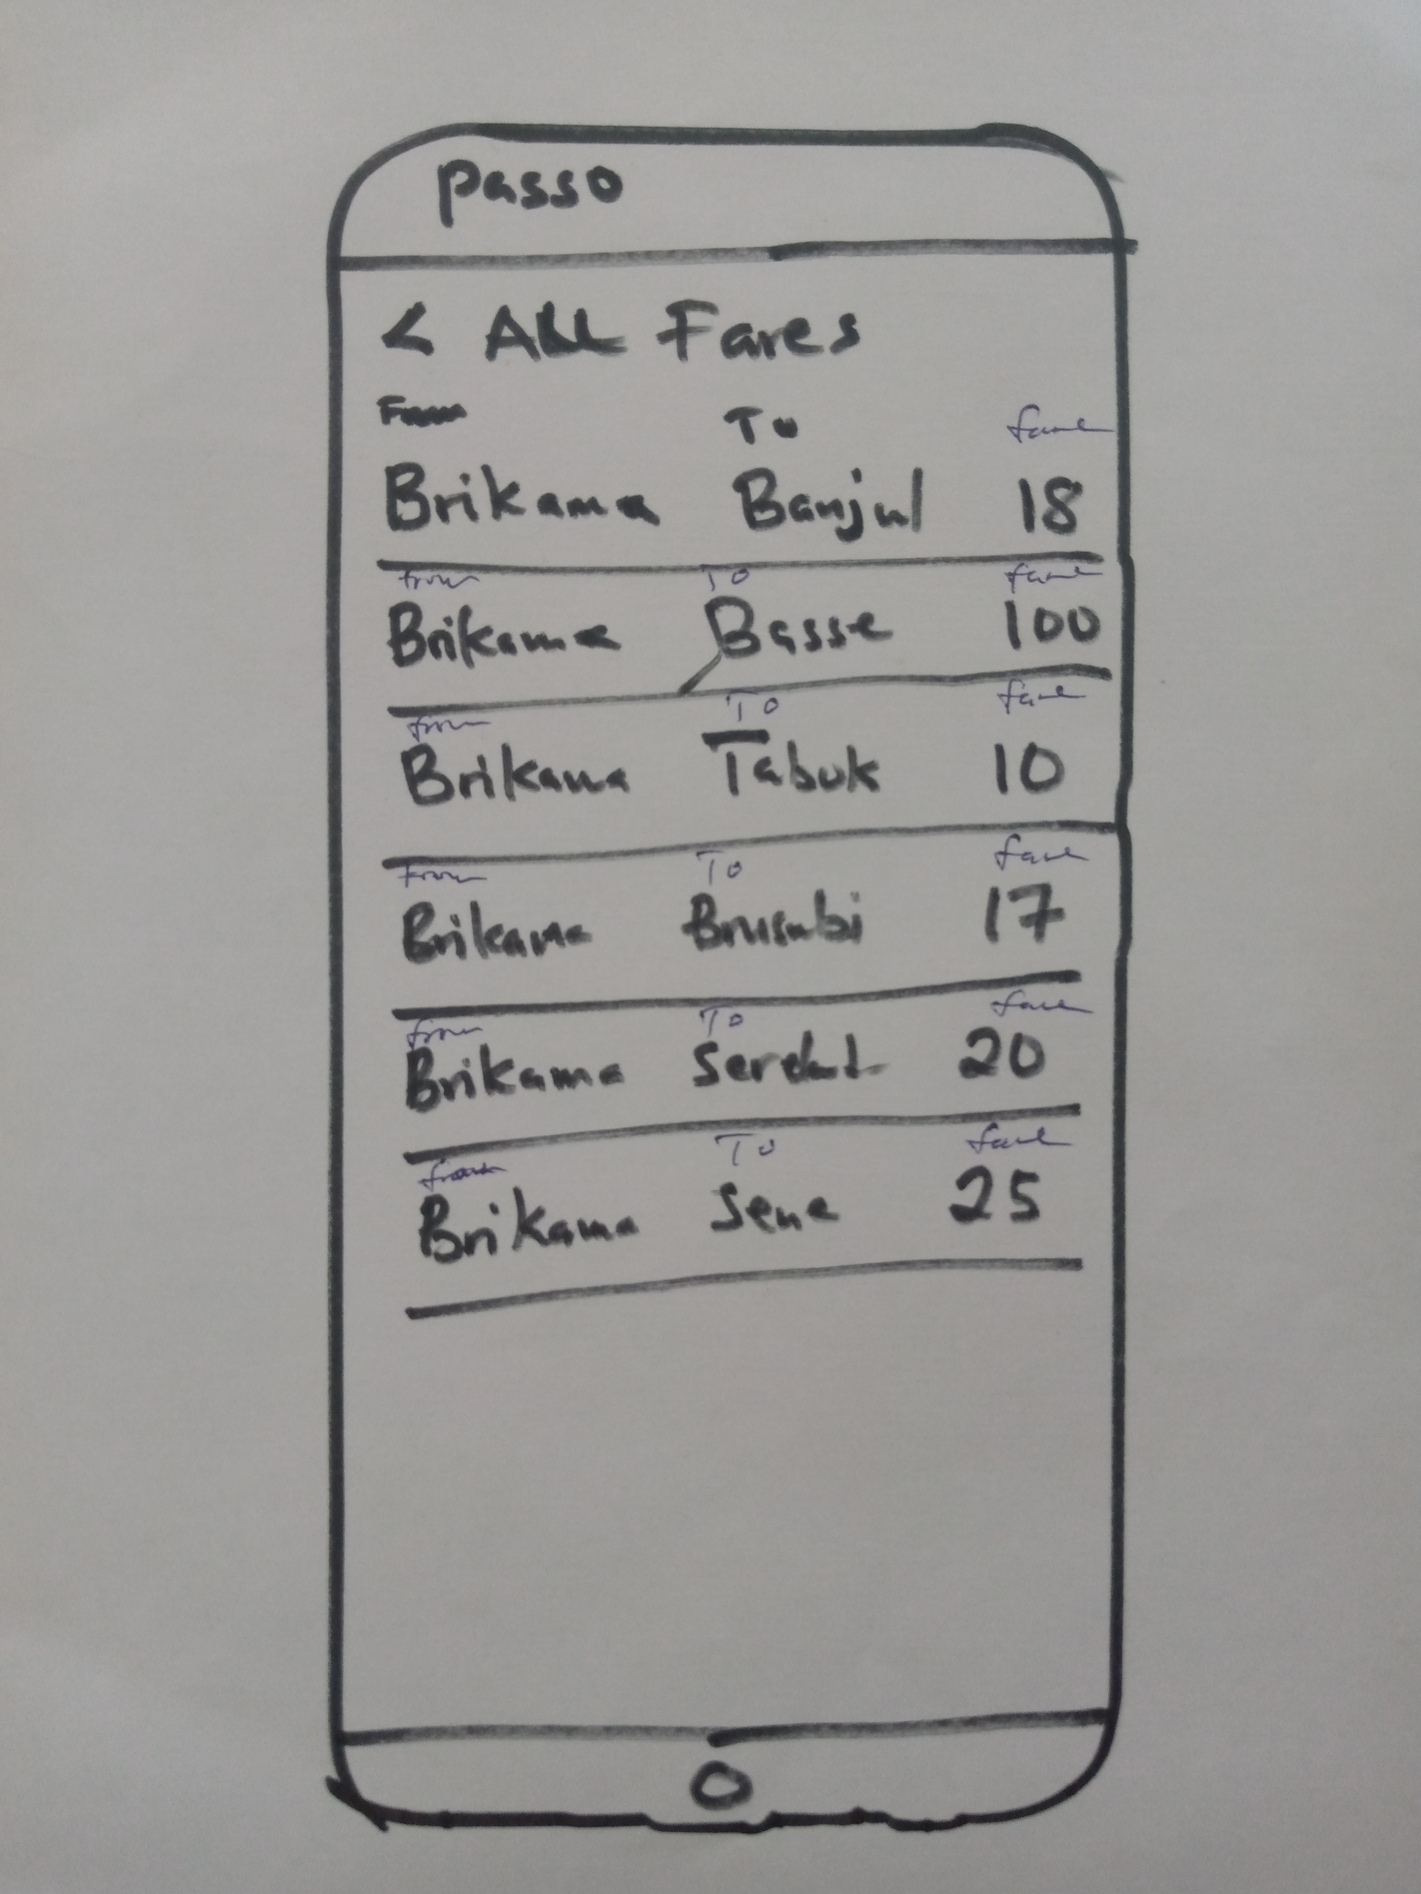

Check Multiple Fare Results  
Iteration 2

**Design principle(s) applied**

* Reduce the things on the fare page
* Add header and back button

**Designs rationale**

* Move the results of the fare to its own space, so that users will only focus on that. Once a user clicks on **How Much?** the results will slide in from bottom and replace the form.

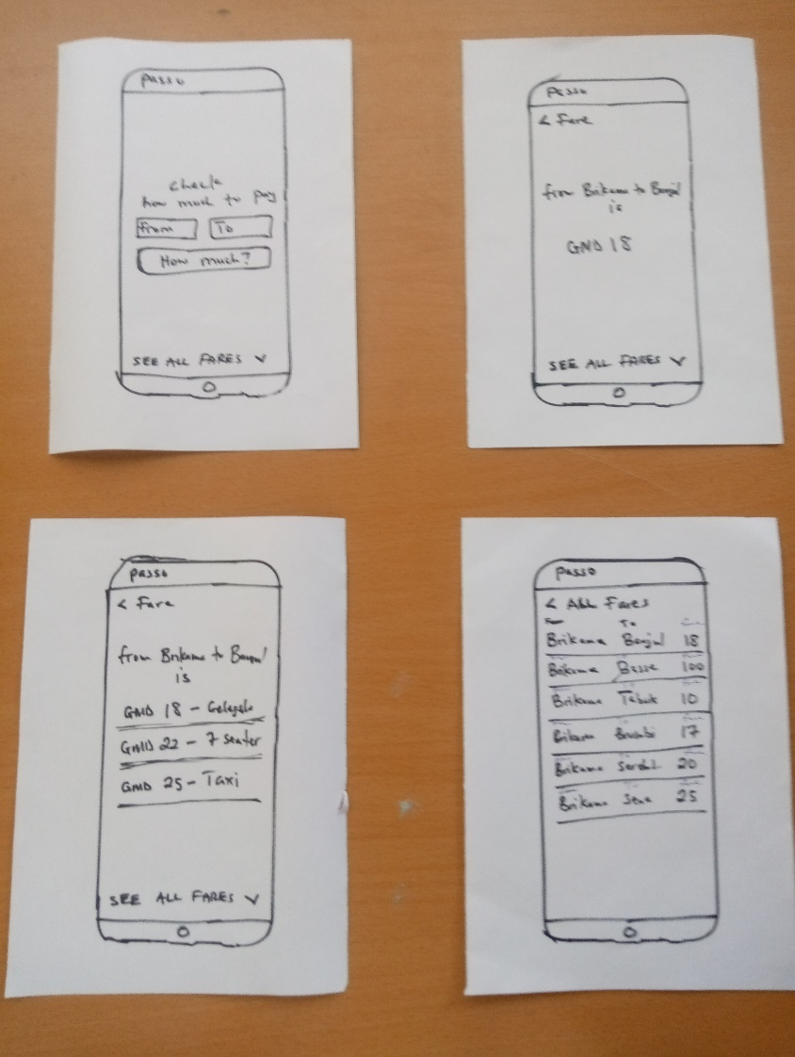

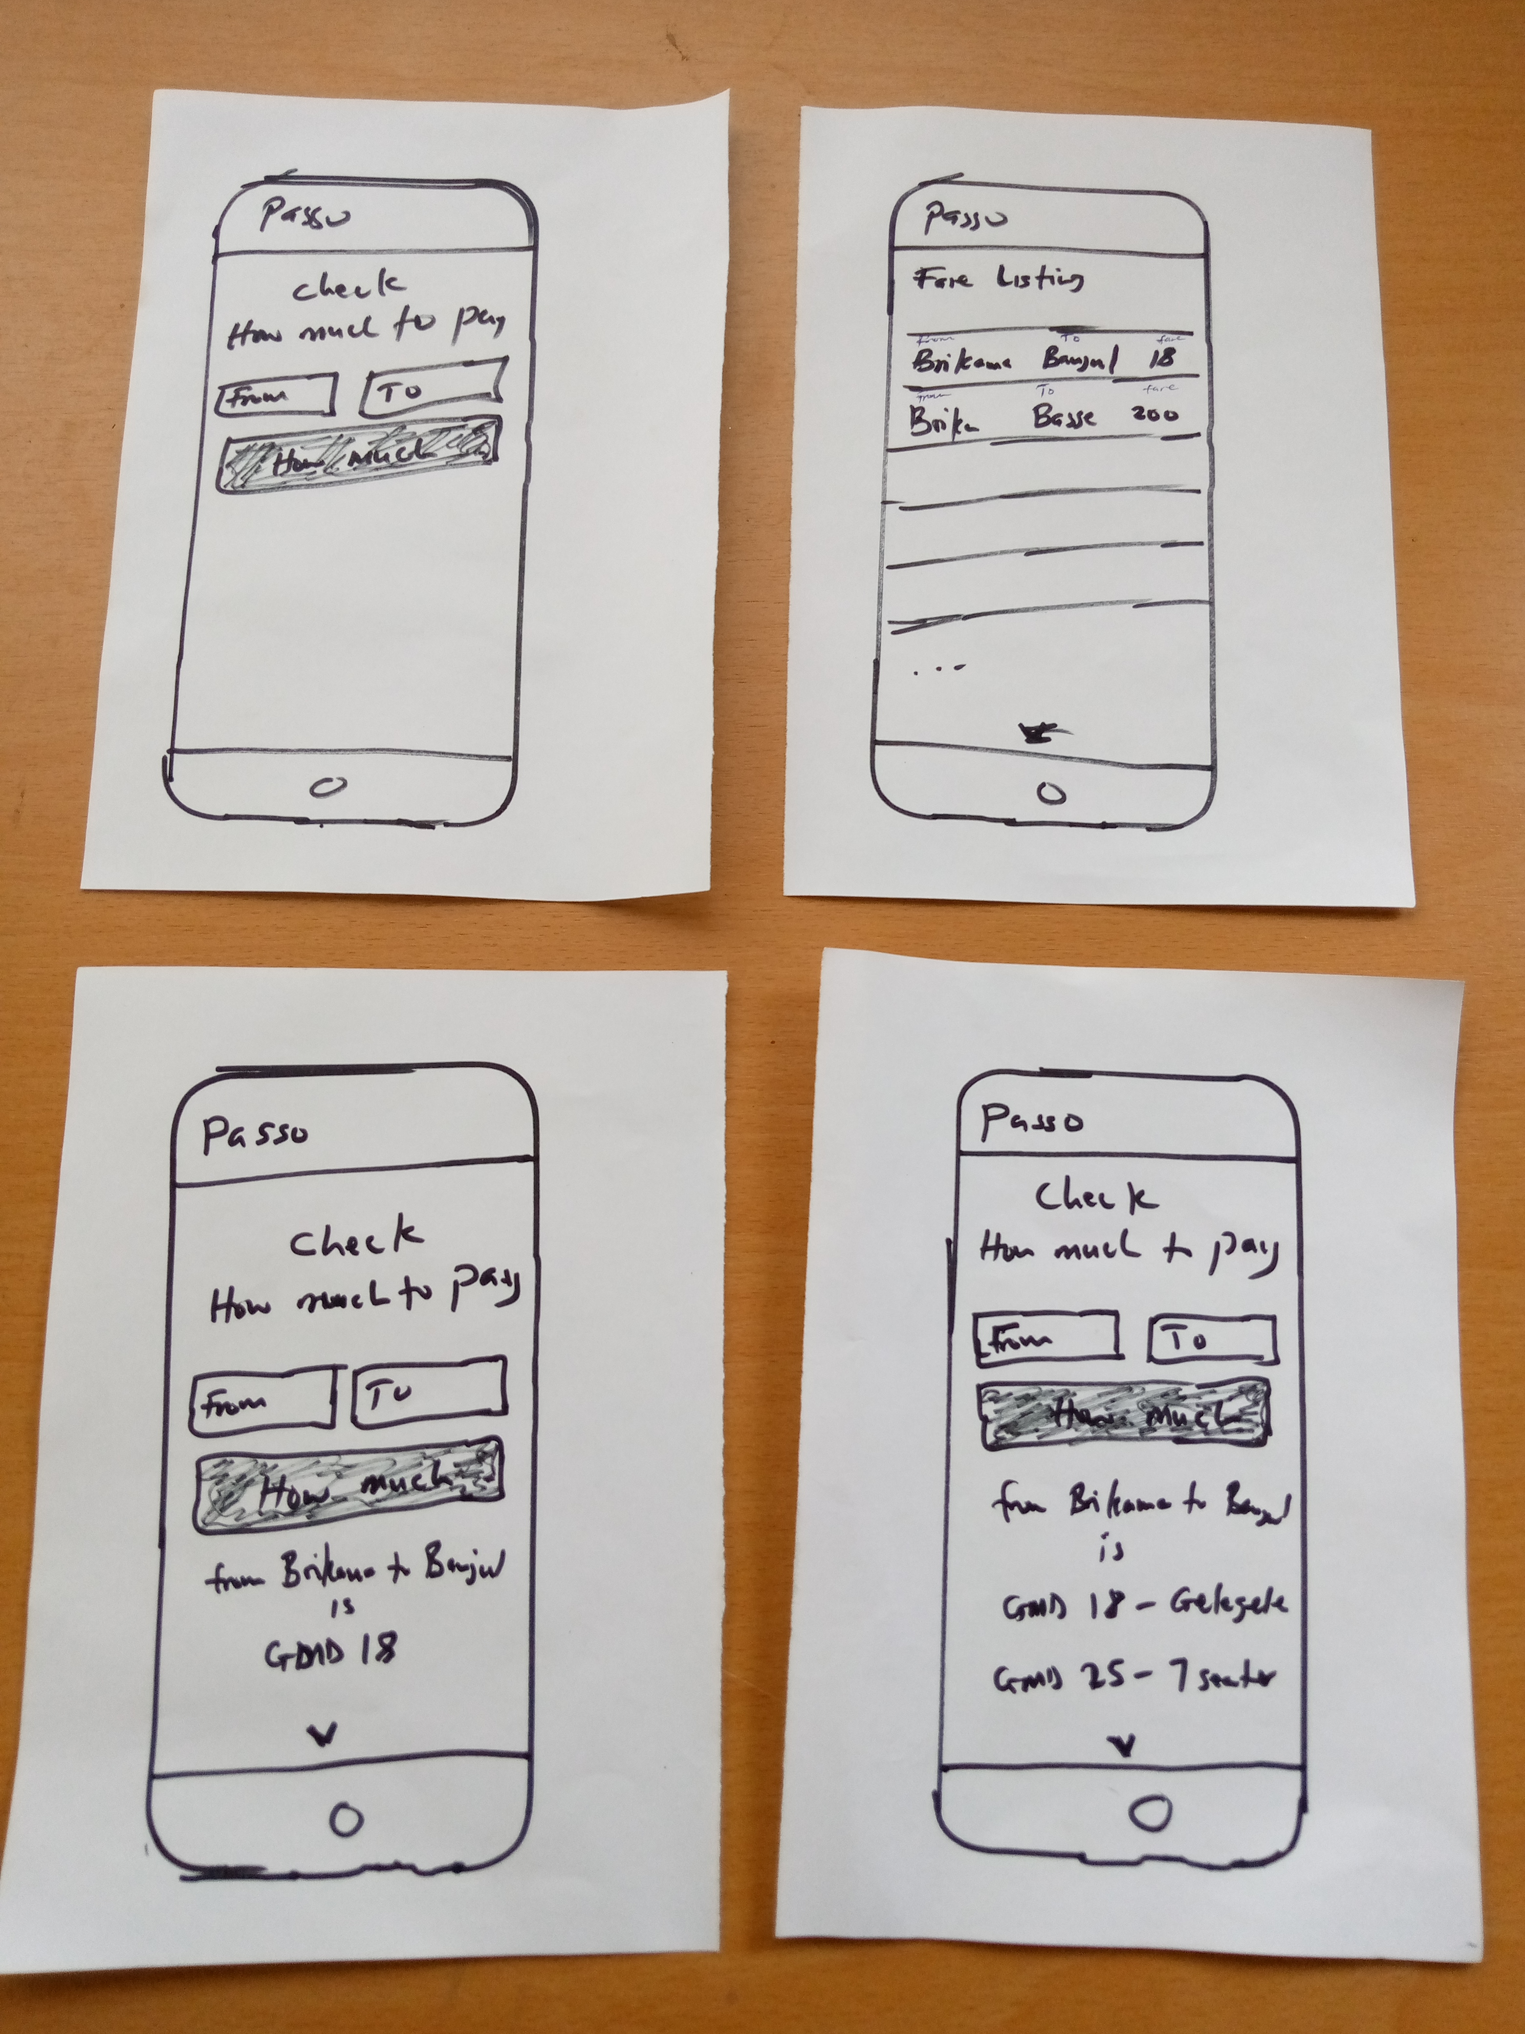

**BEFORE AFTER**